Assignment №9

Cloud and Container Security Exploration: Implementation of Security Policies in Docker and Kubernetes

1. Purpose of the Work

- To study modern approaches to securing containerized environments.
- To implement container security policies in Docker and Kubernetes.
- To perform vulnerability analysis of container images and assess the effectiveness of security mechanisms.
- To develop practical skills in applying security policies to protect applications in cloud infrastructures.

2. Theoretical Background

Modern applications are increasingly deployed in containers, which provide portability, scalability, and flexibility. However, containers share the same OS kernel, which introduces specific security risks.
Key directions for container security include:
- Privilege restriction (via capabilities, no-new-privileges, seccomp, AppArmor, SELinux);
- Image security (vulnerability scanning, minimizing base images);
- Process and file system isolation (using namespaces and cgroups);
- Kubernetes security policies — SecurityContext, Pod Security Standards (levels: Privileged, Baseline, Restricted).

Common container security tools:
docker scan, trivy, grype, falco, kube-bench.

3. Work Plan

Step 1. Environment Setup
- Install Docker Desktop or Minikube (a local Kubernetes cluster).
sudo apt update
sudo apt install docker.io -y
sudo systemctl enable docker –now

~~~
curl -LO https://storage.googleapis.com/minikube/releases/latest/minikube-linux-amd64
sudo install minikube-linux-amd64 /usr/local/bin/minikube
- Verify correct installation:

docker run hello-world
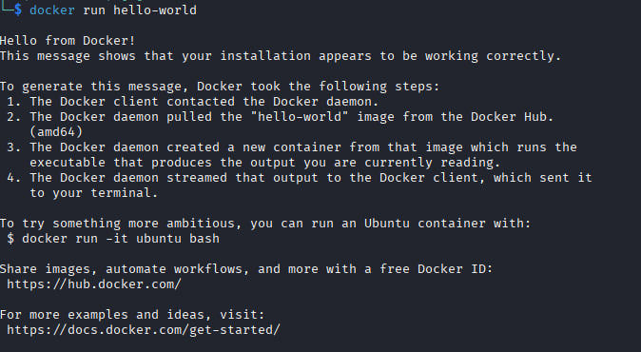
kubectl version
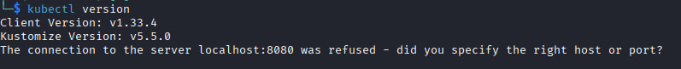
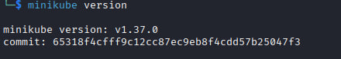
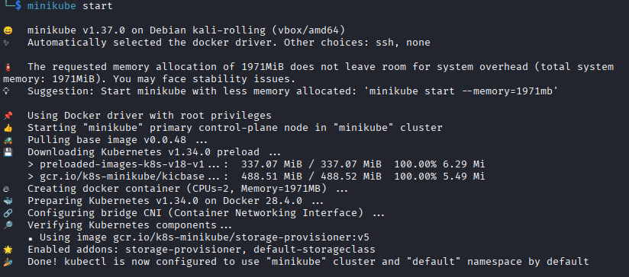
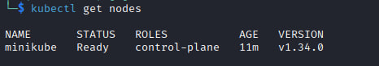
Step 2. Configuring a Secure Docker Container

Run a container with restricted privileges:

docker run -d --read-only --cap-drop ALL \
--security-opt no-new-privileges \
nginx
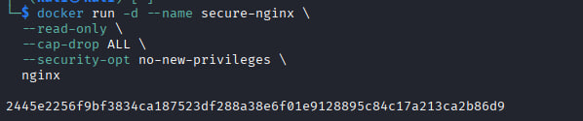
--read-only — makes the container's filesystem read-only → nothing can be modified or written to.

--cap-drop ALL — removes all additional Linux privileges → the container cannot perform dangerous system actions.

--security-opt no-new-privileges — prevents privilege escalation, even through vulnerabilities or setuid → it is impossible to become a superuser.

Check remaining capabilities:

docker exec <container_id> capsh –print
The container stopped immediately after starting. This is normal for nginx if we specified --read-only, but it tries to write logs and can't.

Step 3. Container Vulnerability Analysis

- Install and use a vulnerability scanning tool:
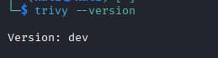
trivy image nginx
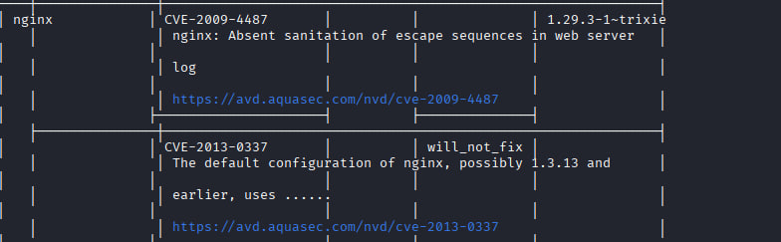
- Record identified vulnerabilities in a table (CVE ID, severity, package, version).
- Compare results for nginx and nginx:alpine images.
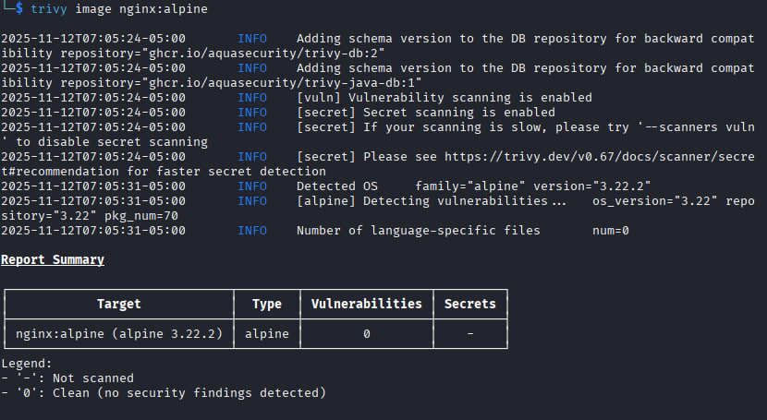

Step 4. Implementing Security Policies in Kubernetes
Create two Pod manifests:
insecure-pod.yaml — without security restrictions;
secure-pod.yaml — with a configured securityContext:
Deploy the Pod and check its status:

kubectl apply -f secure -pod.yaml
kubectl describe pod secure-pod
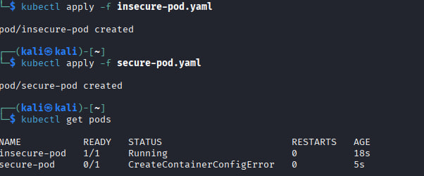
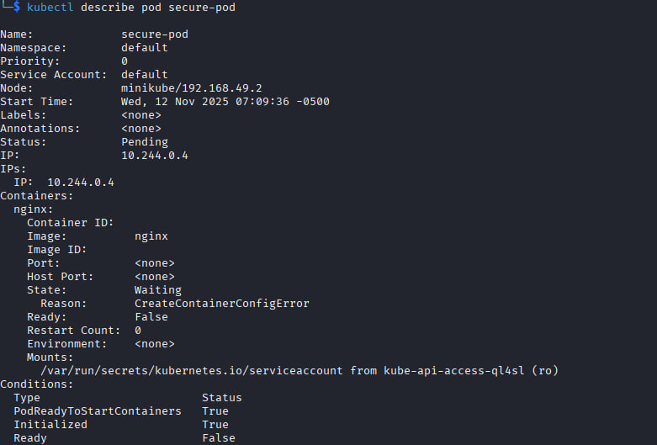
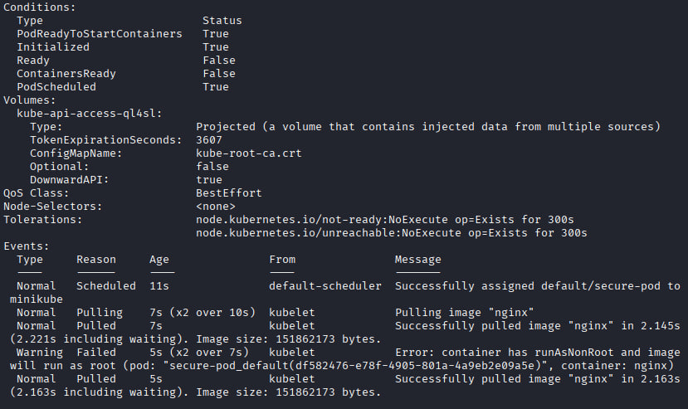

Step 5. Enforcing Pod Security Standards

Apply the restricted security level to the namespace:
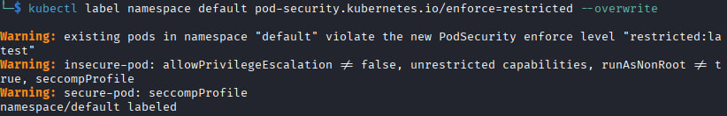
Attempt to launch insecure-pod — confirm that it is blocked by Kubernetes.
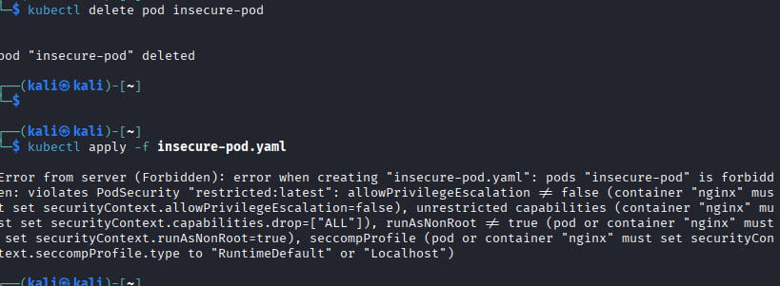

4. Control Questions
1. Which Linux mechanisms ensure container isolation?
Containers rely on several Linux kernel features to isolate processes, resources, and networks:
Namespaces: Provide isolation for various aspects of a container. Examples:
PID namespace – isolates process IDs.
NET namespace – isolates network interfaces.
MNT namespace – isolates filesystem mount points.
IPC namespace – isolates inter-process communication.
UTS namespace – isolates hostnames and domain names.
USER namespace – maps container users to host users.
Control Groups (cgroups): Limit and account for resource usage (CPU, memory, I/O) per container.
Seccomp (Secure Computing): Filters system calls a container can make, reducing the attack surface.
Capabilities: Fine-grained permissions instead of full root privileges.
SELinux / AppArmor / TOMOYO: Mandatory access control (MAC) frameworks to restrict container actions beyond traditional Unix permissions.

2. What does the Docker option --no-new-privileges do?
The --no-new-privileges flag prevents a process in a container (or its children) from gaining additional privileges through mechanisms like setuid or setgid.
Even if a binary inside the container is setuid root, it will not escalate privileges.
Helps prevent privilege escalation attacks.
Syntax example:
docker run --no-new-privileges mycontainer

3. What are the main Pod Security levels in Kubernetes?
Kubernetes defines Pod Security Standards (PSS) as three levels for restricting pod capabilities:
Privileged – Minimal restrictions, pods can do almost anything (least secure).
Baseline – Moderate security; prevents known privilege escalations but allows common workloads.
Restricted – Strong security; prevents privilege escalation, host filesystem access, and host networking (most secure).
These can be enforced via Pod Security Admission (PSA) in namespaces.

4. How can container images be checked for vulnerabilities?
Several methods exist:
Static scanning: Analyze the image without running it. Tools:
Trivy, Clair, Anchore, Snyk.
Detect outdated packages, known CVEs, misconfigurations.
CI/CD integration: Scan images before deployment to prevent vulnerable containers from reaching production.
Runtime scanning: Monitor containers during execution for suspicious behavior.
Example with Trivy:
trivy image nginx:latest

5. Why do minimal base images improve security?
Fewer packages → smaller attack surface: Less software means fewer vulnerabilities to exploit.
Reduced size → faster scanning and deployment.
Simpler maintenance: Fewer updates and dependencies to manage.
Examples: alpine, distroless, busybox are popular minimal base images.

6. How do security policies affect performance and usability of containerized applications?
Restrictive policies may break legacy applications or require code changes.
Limiting privileges (capabilities, network access) can prevent misconfigured apps from running properly.

